**Constructor University Bremen**

RIS Project   
  
Dynamic Obstacle Avoidance

Spring Semester 2023

Zain Samdani

Jaime Garcia

Jose Guzman

**Dynamic Obstacle Avoidance**

1. **Introduction**

Duckiebots face the challenge of safely maneuvering through environments with dynamic obstacles, This project aims to develop a feature for Duckiebots to detect and navigate around dynamic obstacles, enhancing their operational capabilities. By implementing an obstacle detection and avoidance system, Duckiebots can autonomously navigate around other Duckiebots, ensuring safe interactions with obstacles thereby improving their real-world performance. This report showcases the development, methodology, and evaluation of the feature, which utilizes computer vision techniques to detect and analyse the lights in front of other Duckiebots for identification and avoidance.

1. **Motivation**

While Duckiebots are equipped with a lane-following function that allows them to navigate autonomously, the presence of static obstacles, particularly other Duckiebots or other moving obstacles, can disrupt the smooth flow of traffic. When a Duckiebot encounters a blocking Duckiebot on its path, it can move backwards to prevent a collision. In Duckietowns with multiple Duckiebots, this hinders smooth functioning in the Duckietown.

Our Dynamic obstacle avoidance feature aims to enable Duckiebots to detect and pass static obstacles like other Duckiebots without imposing any danger to pedestrians or disrupting the traffic flow. By effectively identifying and avoiding these obstacles, Duckiebots can contribute to the smooth operation of Duckietowns, reducing the potential for traffic jams and ensuring the safety of both the autonomous vehicles and pedestrians.

1. **Objective**

The primary objective of this project is to develop a dynamic obstacle avoidance feature that enables a Duckiebot to safely navigate through a simple Duckietown environment by effectively passing slow or stationary Duckiebots.

In order to achieve this objective, several intermediate objectives are defined as follows:

* Enable the detection of the distance from the obstacle that is closest to the Duckiebot
* If the obstacle is dangerously close (>20cm) make the duckiebot back down until it is at a safe distance away.

To streamline the scope of the project, certain assumptions have been made:

* Only straight lanes without turns are considered.
* Obstacle Duckiebots are assumed not to weave across lanes, ensuring their confinement within their respective lanes.

1. **Preliminaries**

To successfully implement our project, several key preliminaries are required:

* Familiarity with the Time of Flight (TOF) sensor for obstacle detection.
* Understanding of the Duckietown pipeline, particularly its lane-following functionality.
* A fully functional Duckiebot with calibrated camera and wheels.

These prerequisites provide the necessary foundation for accurate obstacle detection, integration into the Duckietown ecosystem, and autonomous navigation with obstacle avoidance capabilities.

1. **Duckiebot detection**

In this project, we made the decision to use the Time of Flight (TOF) sensor as this would be able to detect any obstacle that was dangerously close to the Duckiebot. It could be other Duckiebots, Duckies, or any other random obstacle that it could encounter, and it would still be able to dynamically avoid it.

The implementation itself was using both a safe and unsafe/dangerous distance variable which was established in our code. This distance was chosen to be 20cm. As soon as the program starts running the Duckiebot measures the distance between itself and the closest obstacle and returns FALSE when the object is in a safe distance (>20cm), or TRUE when the object is in a dangerous distance (<20cm) away. If the code returns TRUE then the Duckiebot proceeds to run backwards, succesfully avoiding any collision. The duckiebot continues running the program until told to stop, this way it can avoid the same object multiple times if it continues approaching the duckiebot.

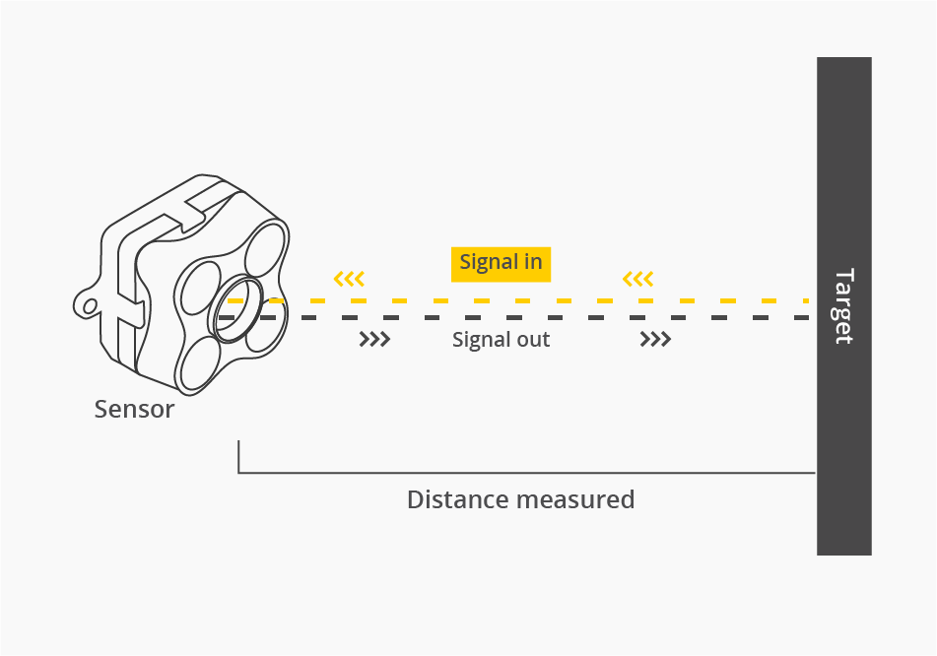

Figure 1: ToF sensor model[2]

The Duckiebot uses an Adafruit VL53L0X Time of Flight sensor. This sensor, as told above, effectively measure the distance from an object to the sensor which is attached to the Duckiebot. The sensor works by using an invisible to the eye laser source, and a matching sensor. This is mainly accurate when determining the distance of objects directly in front of it. The range for this sensor is from 5-120cm, according to the data sheet. [3] The timing budget for the obstacle to be properly detected is 33ms.

All these attributes make it an incredible sensor for our project for various reasons. First, the ToF sensor primarily detecting objects in front of itself allows us to not have to worry about cars incoming from the other lane being detected as a danger, when they are not. The good range from the sensor allows us to detect objects relatively far, but also objects close enough to represent an actual threat to the Duckiebot, making it a bit more realistic. The timing budget being relatively low also makes the dynamic avoidance reliable.

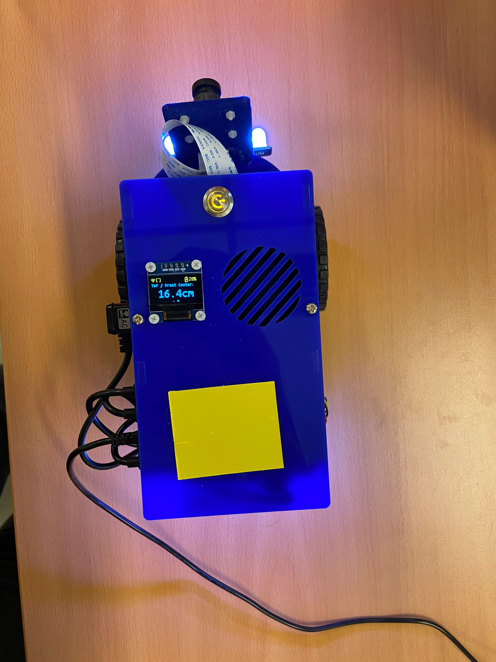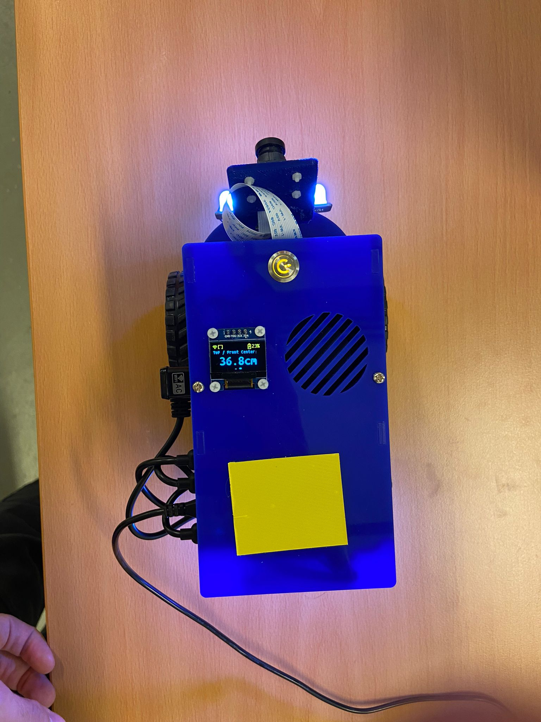

Figure 2: ToF sensor values

1. **Decision logic**

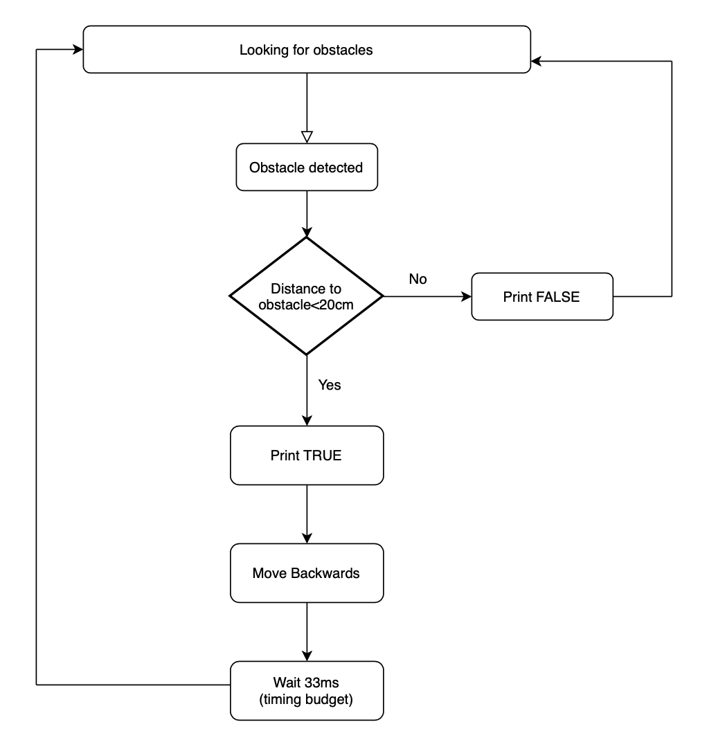



Figure 3: Decision Logic for dynamic obstacle avoidance

1. **Results and Discussion**



The results of our project were highly successful, as demonstrated in the videos showcasing the Duckiebot's ability to detect objects and effectively avoid collisions by executing backward maneuvers. This accomplishment represents a significant advancement in achieving a robust 2-dimensional dynamic obstacle avoidance system.

During the practical application of the project, we observed that the actual performance of the TOF sensor did not precisely align with the specifications mentioned in the datasheet. Various factors, such as lighting conditions and the colour of the surface of the detected object, influenced the effective range of the sensor. As a result, the usable range that consistently provided reliable detection and avoidance capabilities for our project was found to be between 10cm and 100cm.

This deviation from the stated range in the datasheet highlights the importance of real-world testing and adaptation in the development process. By actively assessing the sensor's behaviour under different environmental conditions, we were able to determine a practical range that ensured accurate obstacle detection and avoidance in our specific application.

Despite these variations, the Duckiebot performed admirably and successfully navigated through its environment, effectively responding to potential hazards and avoiding collisions within the established operational range of the TOF sensor. This achievement reinforces the effectiveness of our approach and the capability of the Duckiebot to autonomously navigate in a dynamic and obstacle-rich environment.

1. **Challenges faced**

During the process of building the Duckiebot, we encountered several significant challenges:

* Time constraints and hardware issues

One major hurdle we faced was the limited timeframe for the project, which put pressure on the development process. Additionally, we encountered frequent hardware errors with the Duckiebots, necessitating multiple iterations and replacements. These unexpected setbacks caused delays and affected the overall progress of the project.

* Autonomy and obstacle detection

Achieving autonomous navigation and obstacle detection in a 2-dimensional environment presented its own set of challenges. Designing a robust system that could reliably detect not only other Duckiebots but any obstacles required extensive testing, tuning, and refining of algorithms

* Satisfactory goal achievement

While we strived to meet our objectives, ensuring a satisfactory outcome was another challenge. Balancing the capabilities of the Duckiebot to achieve reliable obstacle detection and avoidance while considering the time limitations and hardware issues posed a considerable challenge.

1. **Future Development**

Looking towards future development, there are numerous aspects in which this project can be expanded and enhanced. Some potential avenues for further improvement include:

* Lane Following

Building upon the foundation of dynamic obstacle avoidance, integrating lane following capabilities would be a valuable addition. This would involve developing algorithms and mechanisms that enable the Duckiebot to stay within designated lanes, maintaining a consistent trajectory while autonomously navigating the environment. By incorporating lane following, the Duckiebot would exhibit more precise and controlled movement, further enhancing its overall functionality.

* Dynamic Lane Switching

Expanding the project to incorporate dynamic lane switching would enable the Duckiebot to adapt to changing road conditions and efficiently manoeuvre through traffic. By detecting congestion or potential obstacles in its current lane, the Duckiebot could autonomously analyze the situation and make informed decisions to switch to a less congested or safer lane. Implementing dynamic lane switching would require advanced motion planning algorithms to ensure smooth and safe transitions between lanes.

* Side Obstacle Detection

In addition to the existing front obstacle detection capabilities, enhancing the Duckiebot's ability to detect obstacles from the sides would significantly improve its overall situational awareness. By incorporating additional sensors or implementing advanced computer vision techniques, the Duckiebot could detect and respond to obstacles approaching from the sides, enabling more comprehensive obstacle avoidance manoeuvres.

1. **References**

[1] Machine learning based lane following - https: //github.com/duckietown-ethz/proj-lfi-ml.

[2] Image for ToF sensor: <https://www.terabee.com/time-of-flight-principle/>

[3] Duckiebot ToF data sheet: <https://learn.adafruit.com/adafruit-vl53l0x-micro-lidar-distance-sensor-breakout>